## Quality Assurance

For a calorimeter of such a complexity, the quality assurance, QA, is a fundamental part of the procurement, fabrication and assembly phases. Quality Assurance will be applied to all components and subsystems and is build on the relevant experience from the CMS and PANDA calorimeters and from the Mu2e group itself. Indeed, within the Mu2e collaboration, the expertise already existing in the construction of the KLOE-2 calorimeter upgrade, as well as the *BABAR* and Super-*B* calorimeters have been useful for carrying out a relevant R&D program that will guide the QA for the calorimeter. We describe in the following our plans divided in three groups: crystals, photo-sensors and electronics.

**10.2.1 QA for Crystals**

In order to achieve the high performances of the calorimeter, strict requirements are imposed on the crystal parameters that have to be controlled, both at the production sites, and upon receipt by Mu2e. The calorimeter is composed of ~ 2000 BaF2 /CsI(pure) or LYSO crystals of hexagonal shape and each of them has to satisfy three different tests: (i) an optical and dimensional inspection, ii) a measurement of their emission spectra and transmission quality and iii) a test of their light yield and longitudinal uniformity of response, LRU. To ensure a fast control of the high production crystal rate (~ 100 /month), the usage of automatized stations is required. In the following we describe in some details, the organization of such a work and the kind of QA already developed for the LYSO crystals. At the moment of writing, we are still studying the final parameters to be used for the BaF2/CsI(pure) acceptance criteria, especially for the control of optical transmission and emission spectra.

***General and dimensional inspection***

For each crystal we require:

1. To be free of cracks, chips and fingerprints. They shall be inclusion-free, bubble-free and homogeneous
2. To be free of curves and to not deviate from a perfect 3-dimensional hexagonal prism by more than 0.05 mm;
3. Mechanical tolerance of ±0.05 mm per side with a 0.3 mm chamfer on all edges
4. Roughness of .XX

The generic *by-eye* inspection will be done at FNAL upon receiving the crystals and opening the boxes inside a dedicated clean room of class XXX. The handling of the crystals will be done only by experienced technicians by means of latex gloves. Each crystal will then go through a dedicated dimensional survey using a CMM, Coordinate Measuring Machine, existing on-site. This facility [ref.] allows through optical scan and precise dimension determination, to control the hexagonal shape at better than 10 mum.

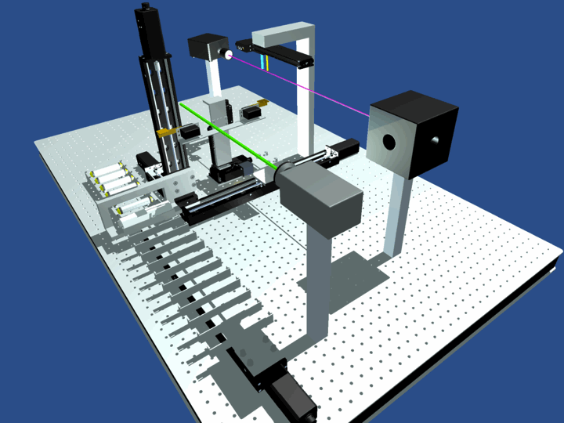

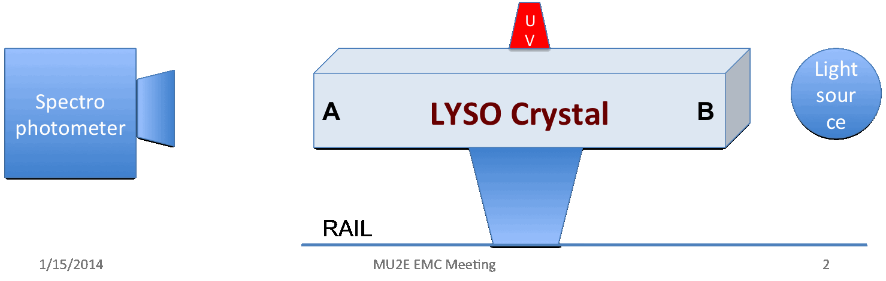

Fig. 1.1 (Top) CAD Drawing of the LATTER station, (Bottom) scheme of light transmission test.

***Transmission and emission tests***

We require each LYSO crystal to:

1. Have a longitudinal transmission above 75% at 420 nm and 80% at 440 nm.
2. Have a transverse transmission be above 75% at 420 nm
3. Pass the overall longitudinal uniformity test by scanning the crystals in 9 points (3 rows of 3 points) along the transversal face;
4. Pass the overall transversal uniformity test by scanning the crystals in 27 points (3 rows of 9 points each) along the longitudinal axis;
5. A test of the emission spectra when running a UV LED along the axis.

These kinds of test have already been carried out both in Caltech and at LNF by means of measurement stations perfectly tuned for LYSO crystals. The station in Caltech is a commercial one, Hitashi-XXX, and is able to measure in the range 200-900 nm so that it is already able to measure transmittance for BaF2 or CsI(pure) crystals. The transmission station at LNF, LATTER (Longitudinal and Transversal Transmission Emission Response), has been designed and assembled during 2013 and is instead tuned in the range 350-900 nm. The CAD drawings and a basic scheme of principle are shown

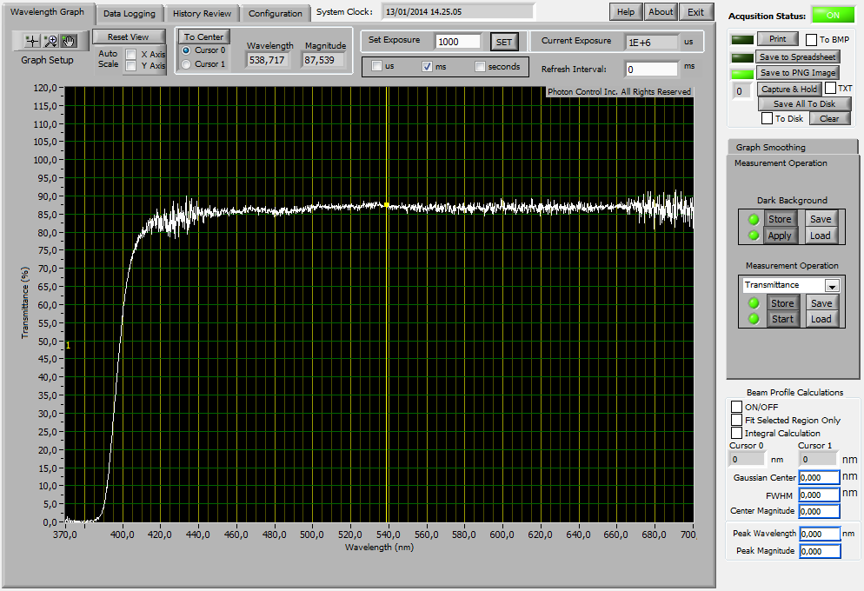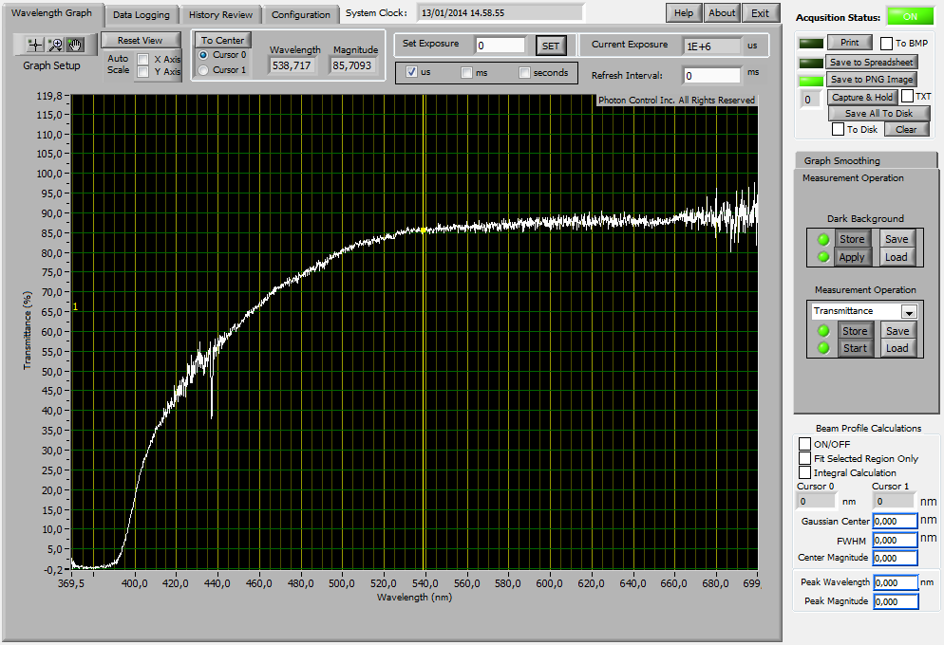in Fig. 1.1. A light source uniformly illuminates the back of the crystal while a spectrophotometer, Ocean-Optics-XX, with a special focusing optics is able to read light coming from a narrow ellipse of 1.5, 2 mm radii. The crystal can be positioned in front of the spectrophotometer by means of a dedicated crystal movement arm and can then be translated longitudinally, adjusted vertically or rotated around its axis by precise step-motors. The whole measurement of transmittance takes 5 sec/point; once multiplied for the number of testing positions, it corresponds to an elapsed time of 10’ per crystal. The sequence of points 3) and 4) used for the uniformity test are driven by a program written in Lab-View and controlled by means of a commercial notebook. At the end of the transmission test, the emission spectra of the crystal is also tested by firing a UV Led (350 nm) over its surface. A more detailed description of the station can be found elsewhere [ref.LNF]. All 25 LYSO crystals used for the construction of the medium size prototype, proto-1, (see sec.xxx) have been tested and qualified for longitudinal transmission by using these stations by acquiring 8 points/crystal; 15 crystals were tested at LNF and 10 crystals were tested at Caltech. Examples of an acceptable and a not acceptable spectra are shown in Fig.1.2-left, 1.2-right respectively. Similar tests have been carried out with the Caltech station as shown in Fig.1.3. Out of 25 crystals, only 1 was found not acceptable from the transmission point of view.

Figure 1.2 *Longitudinal transmittance (%) as a function of the wavelength in nm for (left) an acceptable crystal, C1104-face0, and (right) a bad transmitting crystal, B1106-face3.*

An example of an emission spectra is instead shown in Fig.1.4.left. Interesting enough, we have also learnt how to extract the Moyal law, that describes the emission spectra of the crystals or a generic plastic scintillator (see ref.xx), by fitting it with the equation F = n1 x M1(l1, s1) + n2x M2(l2,s2) where n is the ampliture, l is the average wavelength, sigma is the spread in nm and M is the following law:

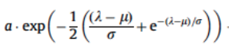

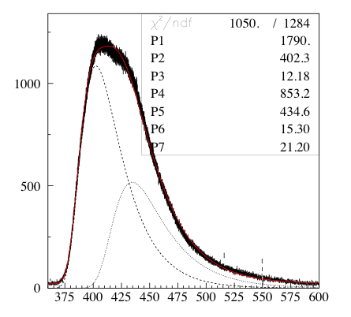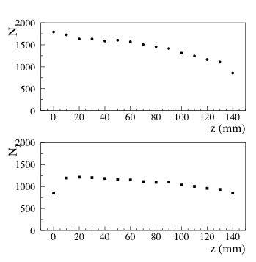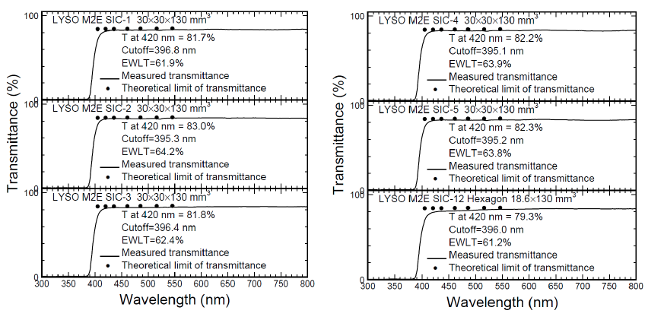

Figure 1.3 *Longitudinal transmission parameters for 6 measured crystals at Caltech. The solid curve is the measured transmittance, the black points are the theoretical limit of transmittance.*

Figure 1.4 *(left) Emission spectra for one of the Siccas Lyso crystal. The most important component is on 400 nm. A relevant component is also existing at 435 nm. (right) dependence of the self-absorption along z-axis. Top plot is for the amplitude of the 400 nm component, bottom plot is for the 435 nm component. While the absorption around 400 nm is almost a factor of t two, the one at 435 nm is smaller than 15% and therefore practically negligible .*

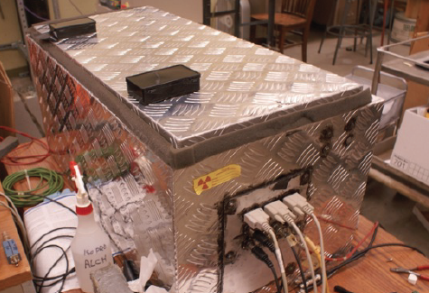

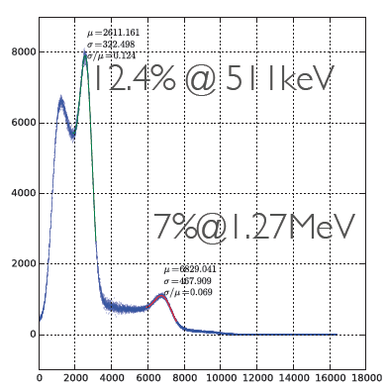



Figure **Error! No text of specified style in document.**.1.5 *(Top) Picture of the QA station for light response in Caltech. (bottom) Spectra of response for a Lyso crystal to a Na22 source (left) Caltech station with APD readout (right) LNF station with PMT reado*ut.

***Measurement of Light Yields and LRU***

We require each LYSO crystal fully wrapped with the ESR-3M reflective:

1. Have a sufficient light yield above 1000 p.e./MeV when readout with a XXX PMT;
2. Have a correct signal shape, 99% of signal below 200 ns;
3. Have a reasonable resolution at 511 keV of < 13 % when readout with a XXX PMT;
4. Have a reasonable LRU, defined as the RMS of the uniformity measurement in 7 or more points along the axis, RMS_LRU< 4%.

All measurements will be carried out in a temperature and humidity controlled environment. A description of the existing control station follows: both the LATTER (LNF) and Caltech stations are based on the usage of a collimated Na22 source that illuminates the crystals in a region of few mm2. Each station is equipped to detect the two 511 keV annihilation γ’s produced by this source, one γ is tagged by means of a small monitor system constituted by a LYSO crystal (3x3x10 mm3) readout by a 3x3 mm2 MPPC, while the second γ is used for calibrating the crystals. Crystals are wrapped, as in the final detector configuration and are readout by means of a 2” PMT or by 1 cm2 APD. In the case of the PMT-readout no additional amplifier is used, while for the APD the signal is amplified by a commercial CAEN-XX charge-amplifier. The tag and test signals are both acquired by means of a CAEN-.. digitizer system at 1 Gsample. A large effort has been done to make used-friendly these QA stations. In the LNF case, all data taking is done by changing the position of the crystals while running a DAQ program at 500 Hz that allow to take a 10000 event statistics in 20 sec. A ROOT macro reconstructs, analyzes and fits the data in less than 30 sec. In the Caltech case, a more panel-oriented approach is followed, displaying to the user data while acquired. Also in this case all analysis and fit facilities are done in an automatic manner. A picture of the existing station in Caltech is shown in Fig. 1.5(Top), while the typical reconstructed 511 keV photon peaks are shown in Fig.1.5.bottom both for the LNF (left) and Caltech (right) stations. Adjustment of the photo-sensors are in progress to make these stations functioning also for the UV-emitting crystals. A 2” PMT UV-extended such as the EMI-xxxxx will be inserted in both cases.

In order to test also the linearity of response as a function of the deposited energy for low values (< 2 MeV) of energy deposition, a linearity-station has been setup in JINR. This station is based on the usage of calibration peaks from many different radioactive sources (AM,FE,NA,Cs,CO ..) illuminating the crystals. We have measured a Siccas LYSO, a Zecotek LFS and a St.Gobain LYSO. Not-linearity observed is below the x % from 50 to 2000 keV [ref.DocDb].

During the production phase, the crystal characterization will be done at FNAL in a cleaning room and one or both machines will be used for the QA procedure.

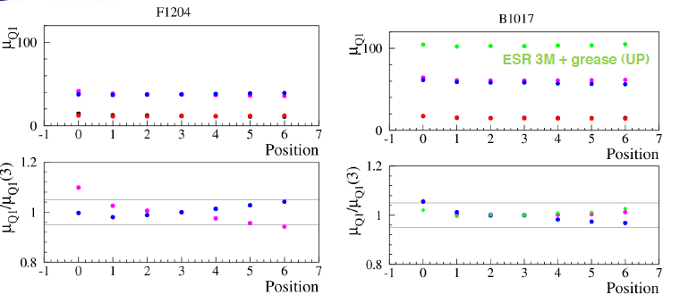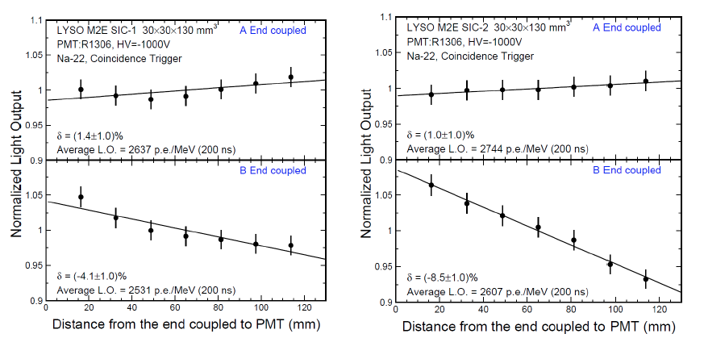



Figure 1.6 *Measurement of the Longitudinal Uniformity of Response of two Siccas LYSO crystals: (Top) LRU as seen by the Caltech Station and (Bottom) as presented by the LATTER station. In both cases, it is shown that the crystals are more uniform when attaching the photo-sensor at one of the two ends while there is an evident deterioration of uniformity when reading from the opposite side. This is interpreted as due to the Ce concentration, CEC, during the crystal growths. Indeed the L.Y. is related to the CE concentration while the uniformity is only related to the reflection and collection of the scintillating light. In one direction … ZHU*

***Acceptance control***

Having described the technique, the acceptance control procedures are here summarized:

1.  ***QA at the site of production:***

Crystals will be tested at the vendor site before they are shipped to Mu2e. A test station will be provided to the vendor along with the set of specifications that each crystal must pass before it can be shipped. The test station will consist of a light tight box and a stepping motor assembly for moving a radioactive source (137Cs) along the crystal axis to measure light yield and LRU.

2. ***QA upon receipt by Mu2e:***

Mu2e will repeat the QA tests performed by the vendor for each delivered crystal Additional tests will also be performed, including a measurement of the crystal dimension and its transmission properties as described above. ***Final crystal acceptance will be based on the tests made by Mu2e.*** As described, we will have two test stations, one in Caltech and one at FNAL in order to share the work on testing the large sample of crystals. We will also export much of our techniques to the final provider(s) for an agreed QA system

3. ***Radiation Hardness testing****:*

In order to control the radiation hardness it will be necessary to measure, on a sampled basis (~5% of the crystals) along the production time, their radiation hardness and recovery time. Gamma irradiation will be performed using a high-intensity 137Cs source at Caltech where a motorized source is already available. Neutron irradiation can be performed at JINR, Dubna. The recovery time will be measured for each crystal.

Given the fact that the final crystals will be of different type, the numbers already decided for the LYSO choice will be modified and corrected properly after a final decision will be taken and a proper adjustment of the stations completed. No problems are expected on this side. Plan is to make a final decision for Q3 2015 after having carried out an internal and an independent dedicated technical review.

**10.2.2 QA for photo-sensors**

The QA for the Silicon photo sensors will be based on the measurement of leakage current and gain and on their dependence on temperature and bias voltage. The APDs will be illuminated by means of continuous blue, green or UV Laser light in order to perform all tests by reading their output current. A schematic of the measurement station already used in Udine for the measurement of single photo-sensor is shown in Fig1.7. If SiPM will be the final read-out choice, there will be also the need of measuring

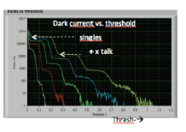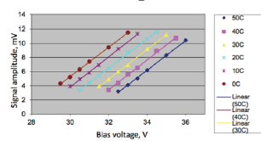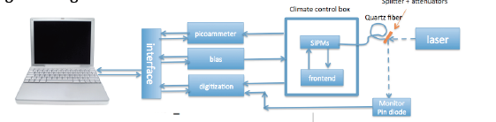

Figure 1.7 *(Top) QA station for single SiPM as developed by the INFN Udine group. (Bottom) measurement of the I-V curve as a function of temperature (left) and of the Gain and single-photoelectron yield as a function of the applied threshold (right) .*

their rate with a Scaler when performing a threshold scan (see Fig.1.7.bottom-right). The conceptual design of a QA station able to measure more photo-sensors at the time and to characterize also their uniformity of response along the surface is shown in Fig.1.8. Three continuous lasers will send light in a diffusing sphere of 1” diameter and funnel it in a bunch of optical fibers so that the light can be distributed over a reasonable number, 5???, of photo-sensors and one reference PIN-Diode. The photo-sensors under test, will receive bias and will be readout by means of a Keithley ampere-meter model XXX, that is fully software controlled. An array of relays will allow to switch from one to the next photo-sensor.. All measurements will be carried out inside a light-tight box and in a tight temperature controlled environment. Moreover, in order to test the quantum efficiency uniformity on the photo-sensor surface, a dedicated motorized system will move the fibers in 16 different reference positions. The value of the leakage current, the gain and the uniformity spread of the QE relative measurement will be used as a tag for the acceptance test or rejection. The gain and the dark rate dependence on temperature and bias voltage will be also determined. Also in this case, an interaction with the vendor will be done to establish acceptance criteria that will however be based on Mu2e final measurement. There will be only one measurement station in Italy for the characterization of all sensors. On a sample basis (5%), the sensors will also be tested under neutron irradiation.



Figure 1.8 *Conceptual scheme for the final QA station for photo-sensors.*

**10.2.2 Other QA**

The preamplifiers and HV boards will be validated using standard bench test measurements of amplification and noise. A burn-in test of the HV board will be also employed.

A final test will be performed on crystals that have been fitted with APDs and readout electronics before they are inserted into a vane. The response of each individual assembly will be tested with a radioactive source. A system test will be performed on the assembled calorimeter using cosmic rays prior to installation in the Detector Solenoid.